Author Name
Professor’s Name
Course Title
Date
Nivea for Men Image Analysis
Introduction
In most cases, in our daily to daily life, we come across advertisements that portray different images with a different meaning. The purpose of the advertisements is to enlighten the customers about the product while persuading them to use their products and services. Most ads have influenced customer choices of the products and services as they convince the customers as being the best. Most of the advertisement has created a positive image for most companies and has become a way of introducing new services and products to the consumers (Abadie, 2011). Images in advertisements have meaning, and it is; therefore, it is essential to analyze the image critically to understand the message portrayed. The essay aims at breaking down the image into the audience, context, and purpose of the Nivea for men advertisement, thus determining the effectiveness of the image. To clearly understand the image, it is essential to consider other image analysis strategies such as color, tone, text, and arrangement of the image. An analysis of “think about your writing” will also be provided after the image analysis.
Image Analysis 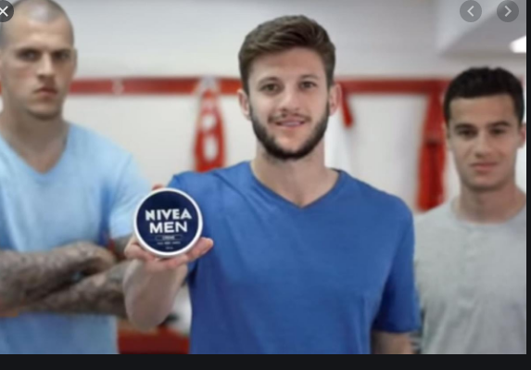
Image from https://www.theguardian.com/tv-and-radio/2015/sep/05/adam-lallana-nivea-advert

Audience
The audience targeted by the above advertisement is men. This is because the background contains three men, while the middle man has the Nivea oil written "Nivea Men." Therefore, the ad is meant to persuade men to purchase the product by encouraging men to take care of their skin. Additionally, women can be an indirect audience because they can also purchase Nivea men for someone else. If you keen on the image, Liverpool FC footballers are the stars in the Nivea moisturizing cream for men advertisement (Golby, 2015). The product leaves the skin moisturized, it’s non-greasy, and fast-absorbing .all these features are appealing to all men of any skin type.

Context
In the above image, the most important context is the Nivea men cream. Based on the popularity of all Nivea brand worldwide specializing in skincare products, Nivea cream for men is one of the most popular product known since 1900. Since then, Nivea has produced the product to hydrate the skin, preventing it from drying. The cream is suitable for the hands, face, and body.
Purpose
The purpose of the advertisement is clear and can be easily understood. Mostly, most advertisements are meant to improve the sales of the product. The purpose of the image above is to encourage the men population to buy Nivea for men cream. Other strategies used in the text include arrangement color and text. In the picture above, there is a substantial arrangement of the three men, but most of the focus goes to the cream that is closer so that the customers can view the image. The color of the product is blue and white, which is the right combination that enhances readability. Additionally, the text of the product is bright with the correct font size on the "Nivea Men."
Conclusion
Conclusively, the ad image is compelling as Nivea is a brand that has created awareness over the past years. It is most likely guaranteed that the Nivea men cream advertisement is effective as they take advantage of the brand name. The ad is effective as the target audience is well-identified through the image.

Think about Your Writing
Question I
The essay's significance is to provide a clear understanding of the Nivea men cream image by explaining the rhetoric situation. I chose Nivea men cream because the product had gained popularity internationally in beauty and skincare for men. I also wanted the image because the ad gained popularity when the company incorporated football players, thus known by most.
Question 2
The draft has utilized the required style and used the appropriate color coding as needed. The image provided in the selection is clear, too, while the theses statement has been stated clearly. The most challenging part of the draft was developing a conclusion as I was to state the brand image's effectiveness without biasness.
Question 3
In the draft above, several strengths and weaknesses can be drawn from the writing. One of the significant strengths in the draft is a good work organization. The work is well organized according to the required specifications. Image analysis in terms of context, audience, and purpose was one of the greatest strengths while writing the draft. On the other hand, one of the weaknesses that I feel the draft writing has is sentences and word errors. Another weakness is errors in pronoun reference. Additionally, I feel as if I had writing deficiencies, especially when giving personal opinions.

Works cited
Abadie, E. A. (2011). Persuasion tactics implemented in multicultural markets: The significance of ethnically tailored advertisements.
Golby, J. (2015, September 5). The new Nivea For Men advert: Adam Lallana takes on the football bullies... with moisturiser. The Guardian. https://www.theguardian.com/tv-and-radio/2015/sep/05/adam-lallana-nivea-advert

